Step 1: Check whether the XAMPP server is running in your machine for PHP and Apache webserver

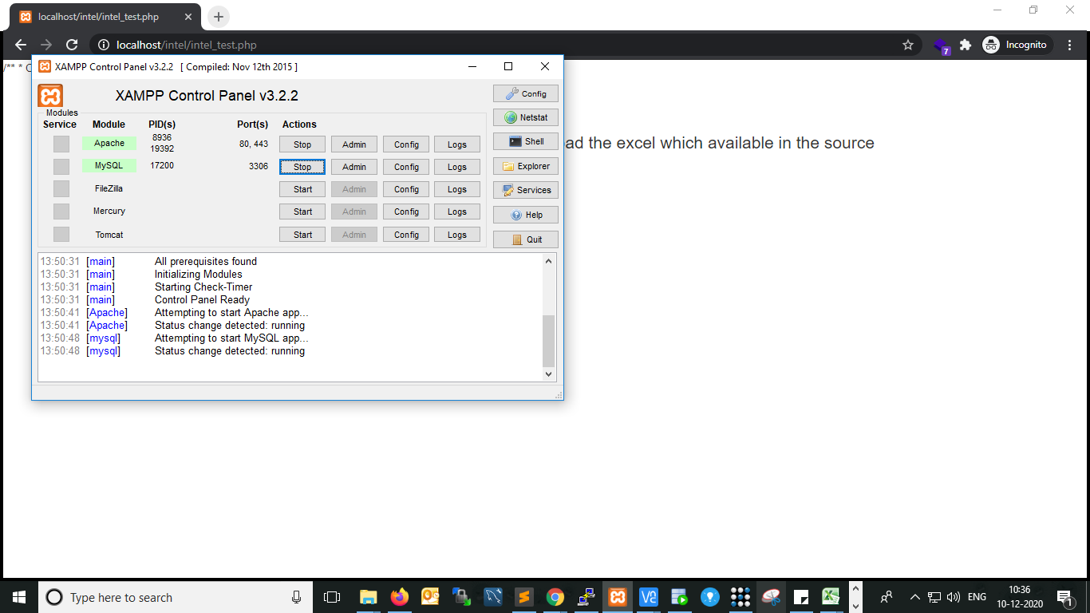

Step2: Download or extract the given source file and place it in your web server path.

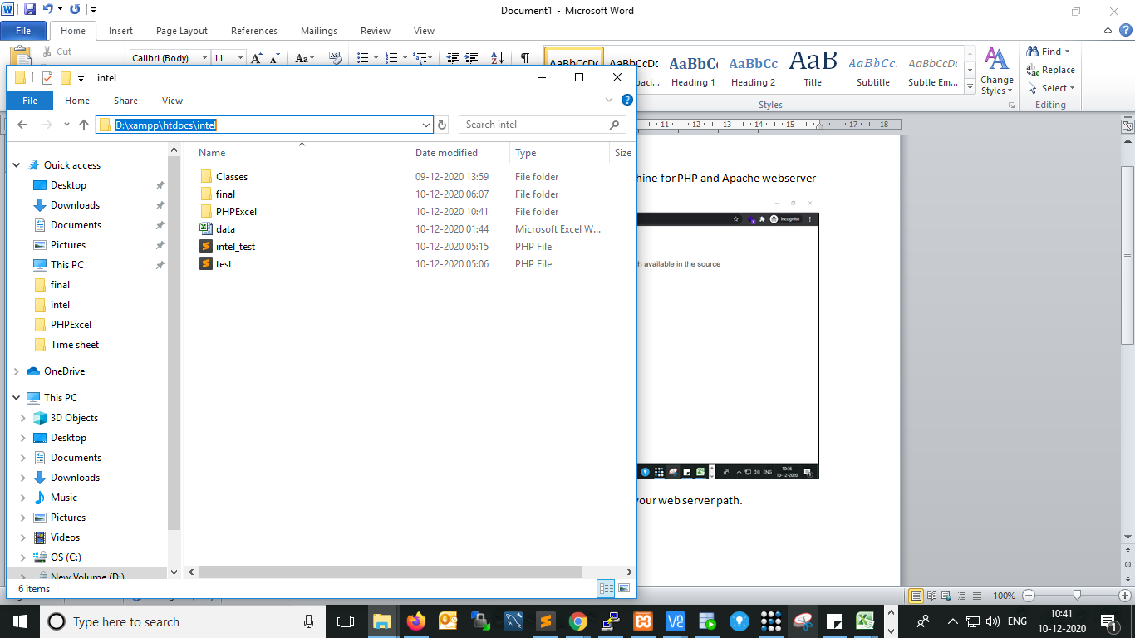

Step:3 Execute or call the source file in any browser using your localhost

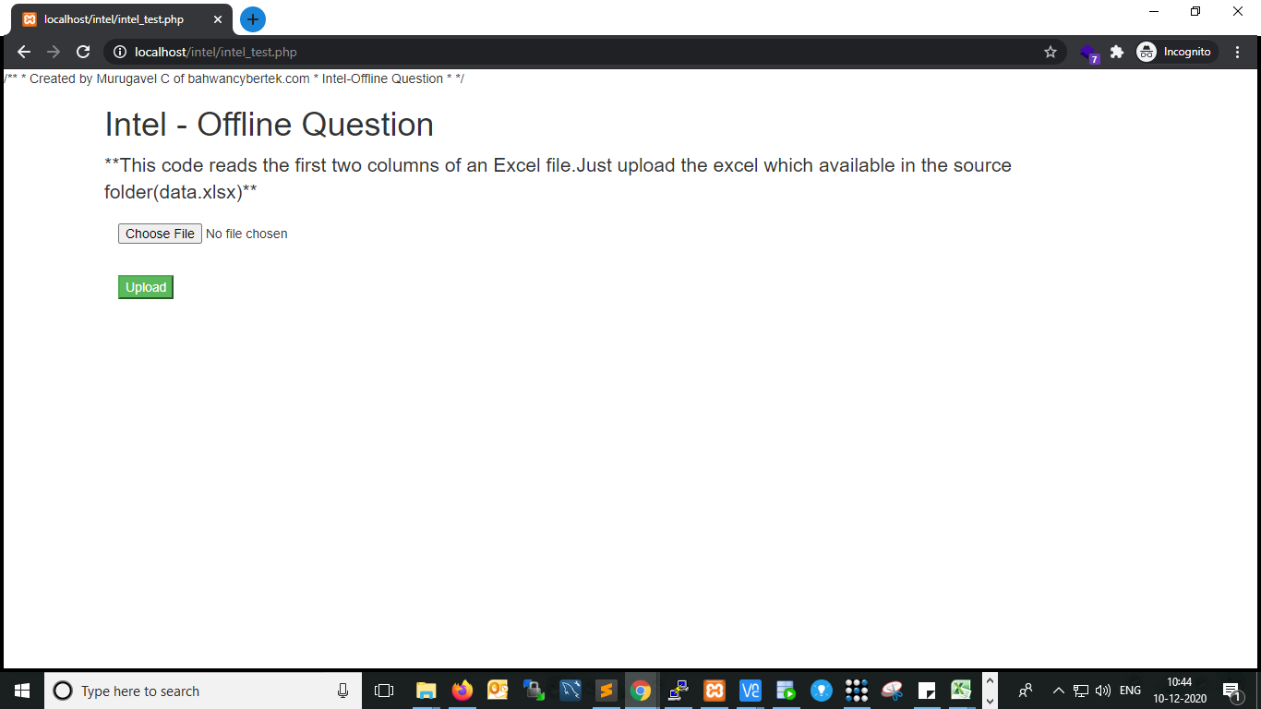

Step4: Upload the given sample data file (excel file available in source folder) then submit.

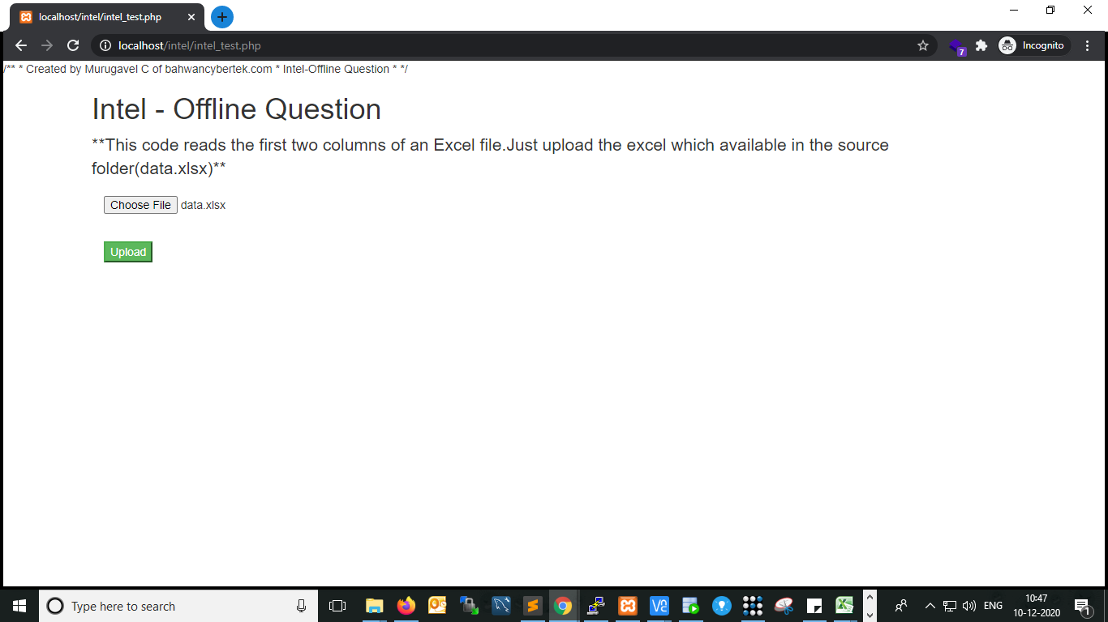

Output:

